MBA Group Profile:  Open Door Customer Service Team |  |  |  |  |  |  |  | 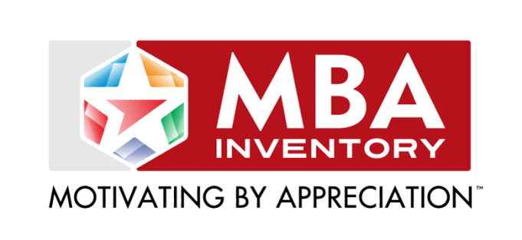
What’s your
language of
appreciation?
 | Words of Affirmation |  |  | Tangible Gifts |  |  | Acts of Service |  |  |  | Quality Time
 | Primary | Secondary | Least  Valued | Primary | Secondary | Least  Valued | Primary |  | Secondary | Least | Primary | Secondary | Least  Valued
Fred
Mary
Joan
Marianne
Chuck
Eric
Becky
Laurie
Marshaun
Ayesha
Helen
Knute
Hannah

